Boss Movement/ Attack Pattern

1st: The Boss shoots out bullets ever few seconds from each side of its body.

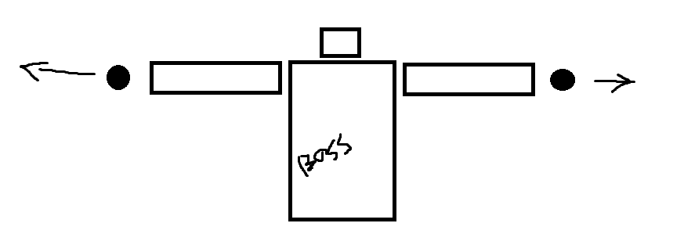

2nd: The Boss has 3 points that it moves between in order. Once the Boss has traveled between the points 4 times, the boss will begin spinning.

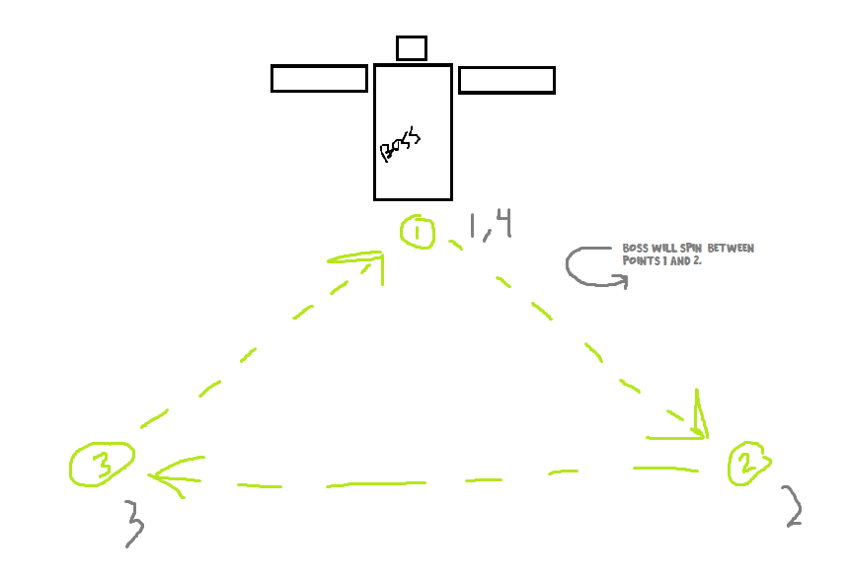

3rd: Once the Boss reaches half health (5/10), bombs will begin to drop at random between -8 and 8 that will do 2 damage to the player.

